**Third Year B. Tech., Sem VI 2021-22**

**Software Engineering Tools Lab**

**PRN/ Roll No: 2019BTECS00113**

**Full name: Sanket Rajaram Mote**

**Batch: T5**

**Assignment No 1**

**Q 1. Create a repository on GitHub named SET Lab and add files into it (you can add implementation files of previous assignment) perform below operations on it. (Add screenshot as an answer to every question)**

**1. Perform commit on added files**

**2. Perform update to the existing files (show history)**

**3. Create another branch**

**4. Create pull request**

**5. Perform merging of both branches**

**6. Perform Fork operation**

**ANS:**

1. I have added previous assignment files:

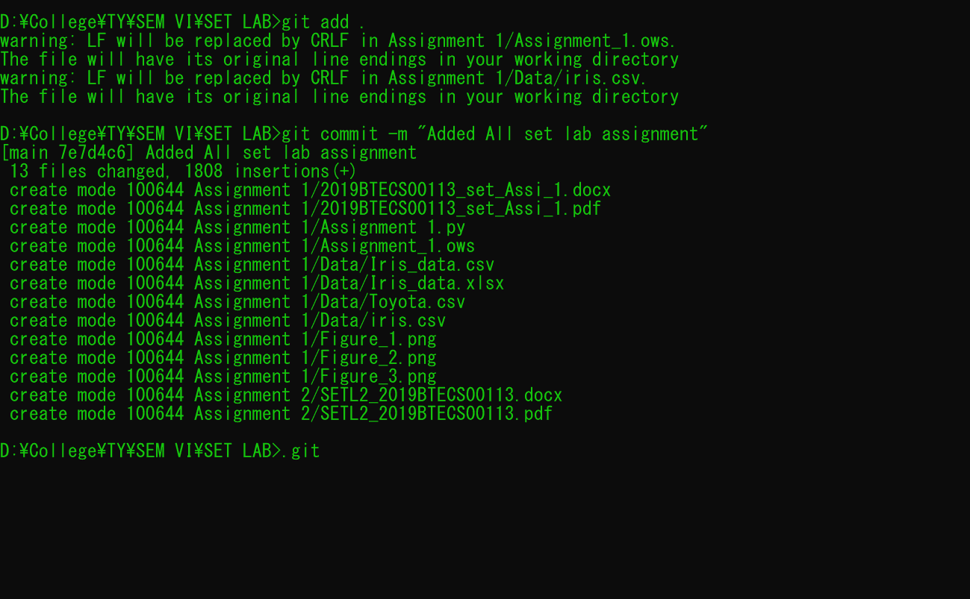

1. .
2. .

**Q 2. For the diagram given below create a GitHub repository and perform operations given in the diagram. (Perform commit operations as given)(Add screenshots as an answer to this question)**